A2632-Asia-India-Tara-Stele-Dark Steatite-c 200 CE

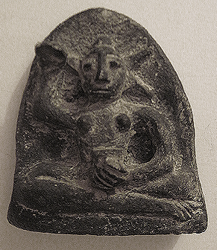

**Case no.: 3**

**Accession Number: A2632**

**Formal Label:** Asia-India-Tara-Stele-Dark Steatite-c 200 CE

**Display Description:**

On this stele, a primitive female Bodhisattva, perhaps an early Tara sits with her right hand held in a boon-bestowing charity gesture, her left hand holds a cup. She is nude except for a crown with five radiations.

**LC Classification:**

**Date or Time Horizon:** c 200 CE

**Geographical Area:** India

**Map:**

**GPS coordinates:**

**Cultural Affiliation:** Buddhism

**Medium:** steatite

**Dimensions:** 84.88 mm, 3.34 in

**Weight:**

**Condition: original**

**Provenance:**

**Discussion:**

Tara is a female Bodhisattva who was believed to have been formed from the tears shed by Avalokitesvara. She is arguably the most popular goddess in the Buddhist pantheon. There are twenty-one forms of Tara but it is the Green Tara and White Tara that are the most popular. She is especially popular in Tibet, Nepal and Mongolia. She is the goddess of universal compassion. Tara represents virtuous and enlightened action. It is said that her compassion for living beings is stronger than a mother’s love for her children. She also brings about longevity, protects earthly travel, and guards her followers on their spiritual journey to enlightenment.